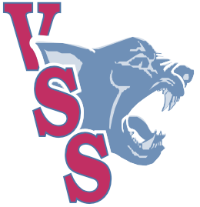
November Newsletter

Vernon Secondary School
“Pride on the Hill”

Principal: Lynn Decker Vice Principal: Andrew Affleck Counselor: Stari Tupper (A-L) Sumeet Parmar (M-Z)

Report Cards/New Semester
The start of term two is today. Report Cards will be available on MyEd BC on November 14th at 3pm. If you are unable to log on to MyEd to view your child’s report card, please contact the office for assistance at 240-545-0701

Careers Department

RCMP Youth Academy – April 19-24, 2026
Any gr. 10-12 students interested in exploring a career in law enforcement are encouraged to apply to Jean Minguy Memorial RCMP Youth Academy.
Cost is $350, which includes food, lodging, clothing, and supplies for the week.
Applications are in the office and counselling area and are due January 15, 2026.
For more information and to submit your application, see Mr. Thorpe on Tuesdays, Wednesdays, and Fridays at VSS.

WORK EXPERIENCE
Are you currently working or volunteering?
Get high school credits for the employment skills you are gaining in the workplace.
Program Details: 120 hours of work = 4 credits
Students must be registered and activated in Work Experience to start counting hours towards the 120 required.
This course can be completed over the summer as well.
See Mr. Thorpe in the counselling area to get started.
Office hours are 8:00am-3:30pm on Tue/Wed/Fri.

Yearbooks are still for sale. $50.00 cash or cheque in the office. Starting in January the price goes up to $55.00. Get your yearbook today so you are not disappointed.

Theatre on the Hill
The VSS Theatre on the Hill company is working hard on set design, construction and rehearsals for our upcoming production, The Murder Was Staged. The play starts as a classic murder mystery but then takes a sharp departure as the actors find themselves in the midst of the real murder of their hated director. Everyone has a motive…even the audience. Will Detective Drake solve the murder? Find out when Theatre on the Hill presents The Murder Was Staged in January.
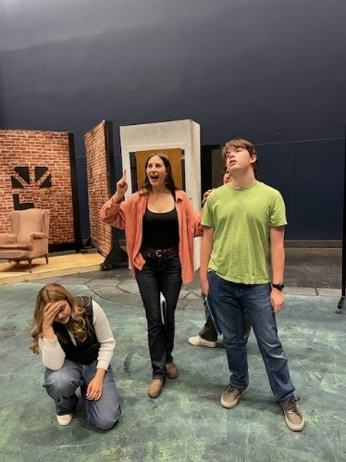
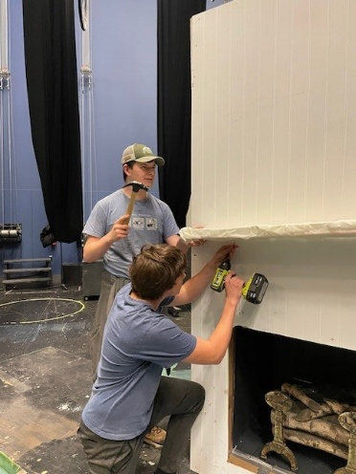
Volleyball
VSS is once again having a strong volleyball season, with a total of 8 teams representing our school in 6 different leagues in the North Zone.
On the boy’s side, our grade 8 boys have started out strong going undefeated in league and coming out on top in several tournaments. This includes the most recent Kal tournament where they won the finals after going undefeated throughout the tournament. The junior boys have been battling in league, with a winning average, and have had strong showings in several tournaments, including 6th at the OKM tournament. The Sr. Boys Volleyball team has really hit their stride in October. Ten members of the team celebrated their Sr. Night by taking top 10 ranked Seaton to 3 tight sets. Team Captain Jeffrey Brown also recently announced his commitment signing to attend College of the Rockies and play for the Avalanche in 2026.
On the girl’s side, we have two strong grade 8 teams who have been competing all year, including at the Penticton tournament where they faced off in the finals, with VSS 1 coming out on top and taking home the gold and VSS 2 taking the silver. Our grade 9 team has had a very strong showing so far this season, with many wins in the tier 1 league and a gold medal finish in Tier 2 at the UBCO tournament in September. The grade 10 girls have had a busy season so far and have finished in the top 5 in three tournaments, including a 3rd place finish at the OKM tournament in October. The Sr. girls’ volleyball is ranked #6 in the province at AAA. They competed against the top teams in all tiers at tournaments this year. The highlight of the season is finishing second at KSS Best of the West and beating #1 AAAA KSS is the quarter finals.

The Sr. Girls are hosting AAA Girl’s Provincials at VSS on Nov. 27-29.

VSS is hosting the AAA Sr. Girls Volleyball Provincial Championship from November 27-29! As the host school, VSS will be one of the 16 teams competing and they are currently ranked 6th in the Province. Coached by Mr. Bertram, Cory Hoard and Callie Bertram, the Sr. Girls team with their parents have been receiving donations for silent auction items that will go live on Monday, November 3, 2025 at the links below. Proceeds will go towards the Volleyball program at VSS as well as some costs to run Provincials. The Tournament Director is Mrs. Bedard. If you are interested in donations or sponsorships for this tournament, contact her at kbedard@sd22.bc.ca. GO PANTHERS!

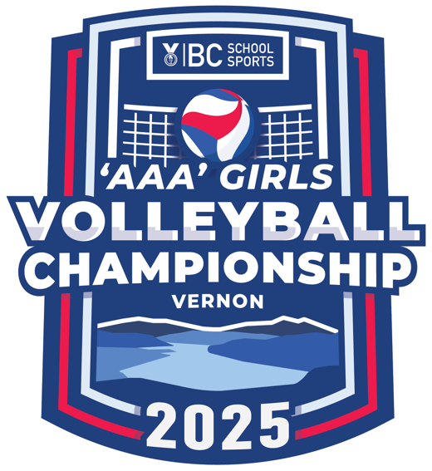

Links to the Silent Auction.

https://www.32auctions.com/VSSSrGirls2025


Cross Country Update
The VSS Cross Country Running Team had a great 2025 season, with 14 athletes training and competing throughout the Fall. Our Junior Boys’ team were the stars this year, winning our home race at Kal Park, as well as at Ellison, and at the North Zone Championships in Salmon Arm. The team, led by multiple race winner Kaydn Dunbar, then went on to take second place at the Thompson-Okanagan Championships in Penticton. Unfortunately, the whole team could not make the road trip to Nanaimo for the Provincial Championships, but the two who could, joined with our two Junior Girls, who qualified individually, to compete in Vancouver Island’s pouring rain and mud. In both the Junior Boys’ and Girls’ races, against almost 300 of the best in BC, all of our gutsy crew exceeded their own expectations, finishing well within the top half of the field. After being our loan competitor at last year’s Provincials Ivy Callihoo was hoping to crack the top 100 this year, and she smashed that goal, ending out the season as our top finisher, in 58th.
Now, all of our runners are moving on to their winter sports, skiing, basketball, hockey, swimming, curling… with a great core fitness base and competitive toughness.

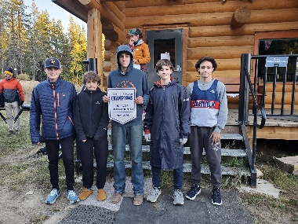
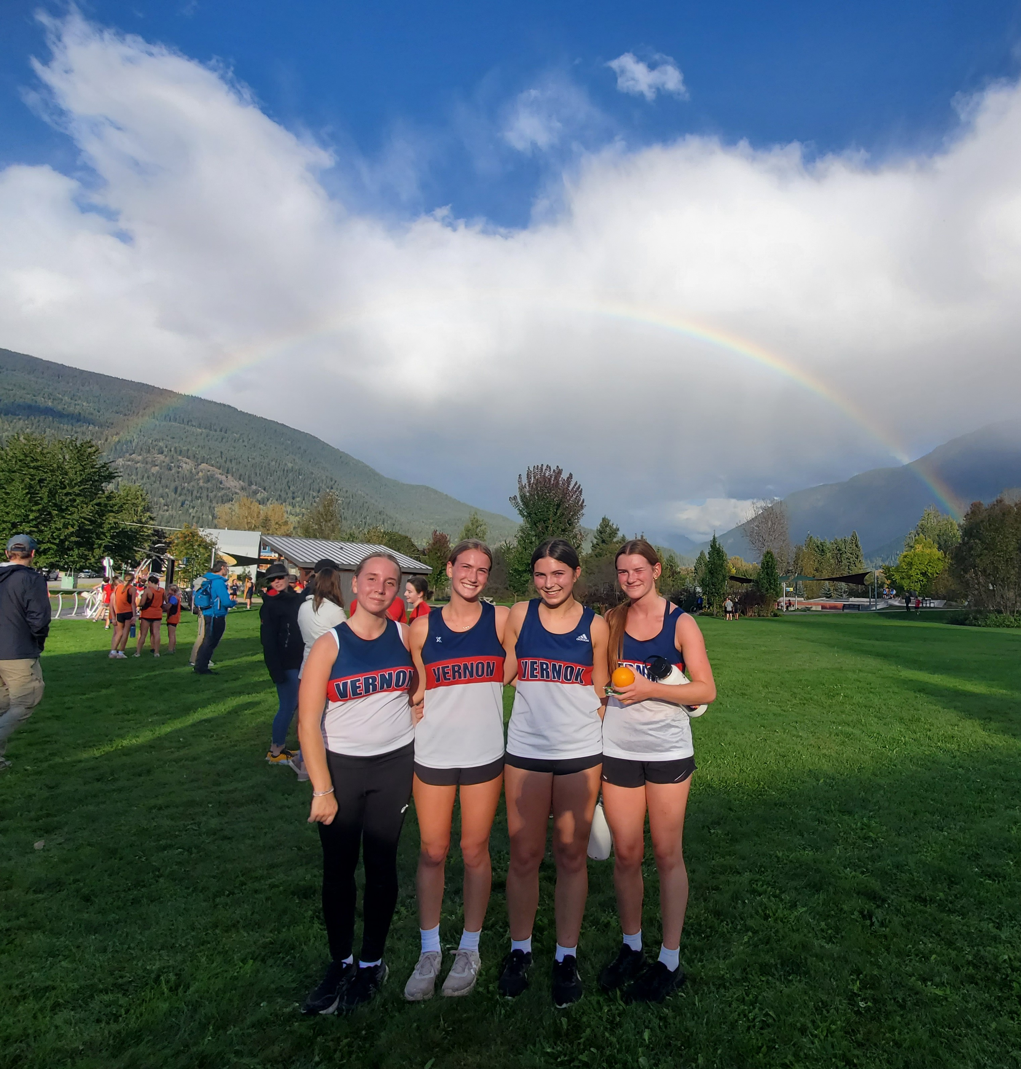
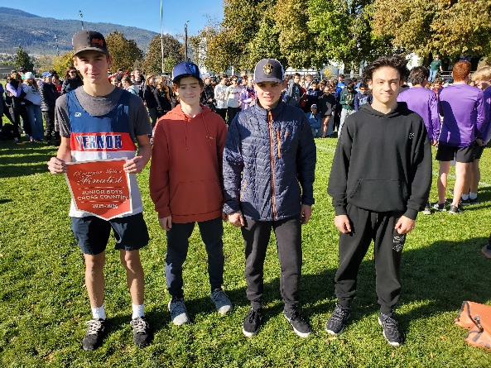

VSS Students Attend BC Student Leadership Conference
On October 23rd to 26th, eight students and two teachers traveled to Tsawwassen to attend the annual BC Student Leadership Conference. Four students from Student Voice and four from Leadership listened to motivational speakers, engaged in workshops, and connected with students from all over BC.
Eve Munro, Linnea Guay, Lara Burfitt, Teagan Giroux, Alexis Creamore, Mina Nadeau, April Gardiner, and Manavmeet Kaur attended the conference, along with Mrs. Smith and Mr. Kopy.
The VSS students also got to take part in a huge "clean up the beach" project in which they collected hundreds of pieces of garbage from Tsawwassen shorelines. Thank you to the Okanagan Learning Foundation and to the VSS PAC for making this experience possible!

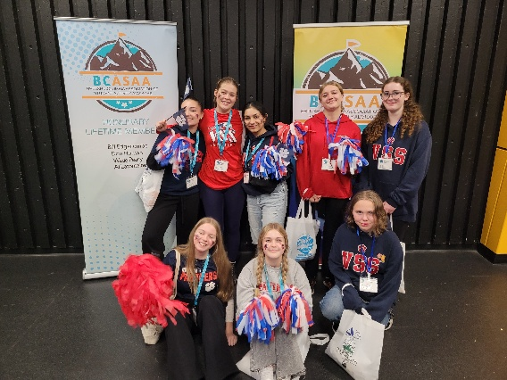
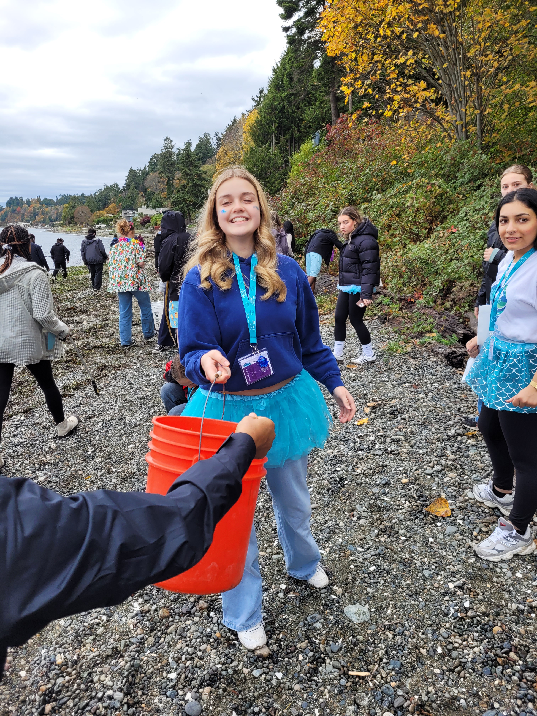
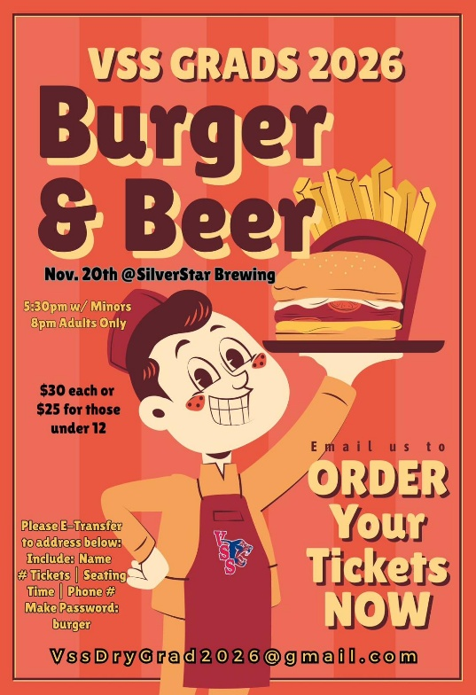
Grad 2026 Fundraiser!

Upcoming Events

November 12 Grad parent meeting 6pm
November 14 Q1 Learning Update released to MyEd
November 18th PAC meeting at 5:45 Doug Rogers to present on mental health and vaping
November 27th VSS hosting Sr Girls Volleyball AAA provincials
Dec 1 – 5 Grad Photos all week. Appointments booked online
December 7th “I” reports sent home this week
December 15th Rotation 4 starts for grade 8’s
December 17th Locker Cleanout
December 19 Last Day of school before winter holidays
January 5th School Reopens

