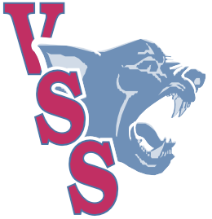
Vernon Secondary School
“Pride on the Hill”

VSS Grad 2026 Timeline

Rehearsal Day Wednesday, June 17th, 2026
Grads pick up gowns in basement 10:30 am
VSS Grad Gown picture on front steps 11:10 am
Grads meet in the commons for bussing 12:00 pm
Rehearsal at KTP 12:15 – 1:30 pm
Busses Depart KTP 1:45 pm
Busses arrive back at VSS 2:00 pm
Grads return to theatre 2:00 pm
Prom Rehearsal to follow 2:10 – 2:40 pm

Grad Ceremony, Thursday, June 18th

VSS Final Set up at KTP 11:00 – 2:00pm
Grads arrive at KTP – line up in tunnel 3:15 pm
Commencement Ceremony 4 – 5:30 pm

Prom/Dry Grad, Friday, June 19th

Grads meet at VSS in Commons 1:00 pm
Grand March through the School 1:10 pm
Picture on front step in gown/tux 1:30 pm
Family Time and Pictures (Students to organize) 1:45 – 6:15 pm
Grads arrive at VSS and gather in theatre 6:15pm – 7:00pm (Doors close at 7pm)
(Security Check at library doors)
Grad promenade in Gym 7:15 pm
Program/Speeches 7:45 – 8:45 pm
Prom Dance 8:45 – 9:15
Dressing Rooms open for changing 9:00pm – 10:00pm
Grads assembly into theatre to hear of activities 9:30 pm
Dry Grad Celebration 9:30 – 1:30 am

2100 - 15th St. Vernon, BC V1T 9X7 | website: vss.sd22.bc.ca | phone: 250-545-0701 | email: vss@sd22.bc.ca

